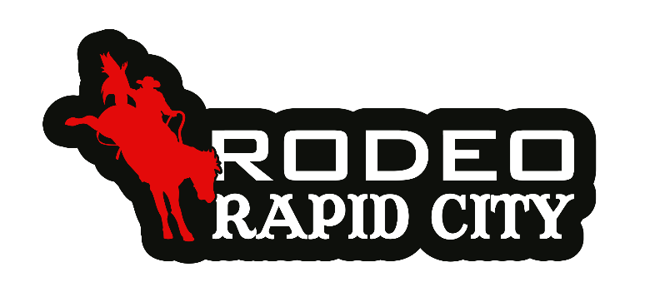

Presented by Brink Constructors Inc.
Jan 30th– Feb 7th, 2026
Produced by: Sutton Rodeo Inc.

Position:
- Rodeo Rapid City Marketing/Event Management Internship
- Location: Rodeo Rapid City, the Monument, Rapid City SD, January 28-February 7, 2026

Program Purpose:
To provide an elite opportunity to gain training and hands-on work experience in ag marketing as well as event production through one of the natation’s industry leaders; Rodeo Rapid City.
- Qualifications
  - Preferred:
    - College student at an accredited university at time of application
    - Minimum 3.0 GPA
    - Background in the agriculture industry or enrolled in an agricultural field or marketing major.
- Must Possess:
- Exceptional oral and written communication skills.
- Great organizational skills and be very detail oriented.
- A strong work ethic.
- Self-motivation and the ability to work on task with minimal supervision and maximum productivity.
- A positive attitude.
- Creative problem-solving skills.
- The ability to work well with others.
- Strong integrity.
- Be available to work Jan 28 – Feb 7, 2026, in Rapid City, SD, including weekend, days and evening hours.

The Internship:
The internship program will provide up to four qualified applicants with the opportunity to assist in aspects of event production, marketing and execution for Rodeo Rapid City.
  - Support marketing & production staff.
  - Attend events as assigned.
  - Write press releases.
  - Conduct interviews to be used in marketing materials.
  - Capture photos & video of all events assigned.
  - Create daily social media content of the events.
  - Provide customer service to attendees, production office & tradeshow support.
  - Assist with all areas of event execution as assigned.

Compensation:
While this is an unpaid internship, Rodeo Rapid City will provide all interns with:
- Lodging
- Two meals per day
- Rodeo Rapid City interns will be invited to special events throughout the ten days and have the opportunity to network and gain invaluable hands-on experience from an industry leader.
- Interns are responsible for their own transportation to, from & for the duration of the event.
- It is the intern’s responsibility to initiate and coordinate college credits for this internship with his/her college.

Deadline to Apply:
Applications will be accepted until, December, 1st 2025, at 11:59 pm Central time.
Questions? Please contact Amy Muller at suttonrodeo@venturecomm.net.
- Interested applicants should submit:
  - Cover letter, resume and three professional references.
  - Brief Biography including: where are you from, what college you are attending, major, prospective career plan, why you want the opportunity etc.
  - Headshot or other appropriate picture to use for event production.
Finalists will complete an interview process and applicants will be selected and notified no later than Monday, Dec 15th, 2025, 11:59 pm Central Time. Applications accepted only by email suttonrodeo@venturecomm.net, please reference “Rodeo Rapid City Internship” in the subject line.
If selected, contact your academic advisor or department internship coordinator to register of internship credits. We understand that RRC will overlap with your spring class schedule; while professors are normally willing to work with you, if selected, it is your sole responsibility to contact your advisors in advance and arrange for any necessary make up work before you attend the event. RRC is a fast-paced production and you will not have time to do your makeup work during the event dates.

